

**UNIVERSITI MALAYSIA TERENGGANU**

**CSM 3103 PROGRAMMING FRONT-END**

**BACHELOR OF COMPUTER SCIENCE (MOBILE COMPUTING)**

**LAB 5**

**SEMESTER II 2023/2024**

**PREPARED FOR:**

**DR. RABIEL BIN MAMAT**

**PREPARED BY:**

**NUR IZZATI NAJWA BINTI MOHD BAKHRI (S65417)**

**Task 1**

1. What is the id of button and input field

- input id="input_color" and button id="button_change"

1. What happened when you clicked change button and why?

- It doesn’t change anything because the code doesn’t complete.

Test and evaluate your code. Comment on the new behaviour of your code

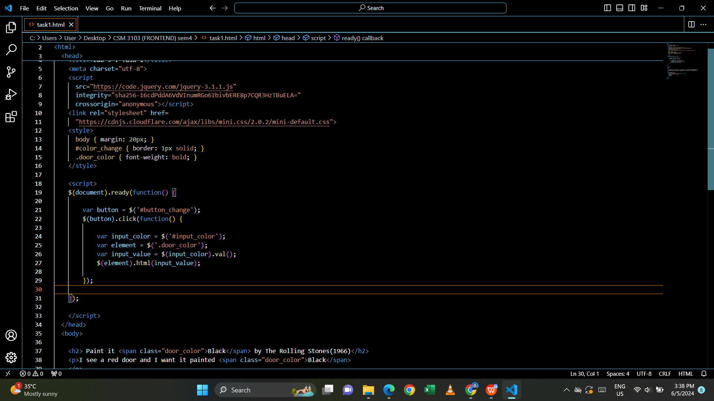

Output:

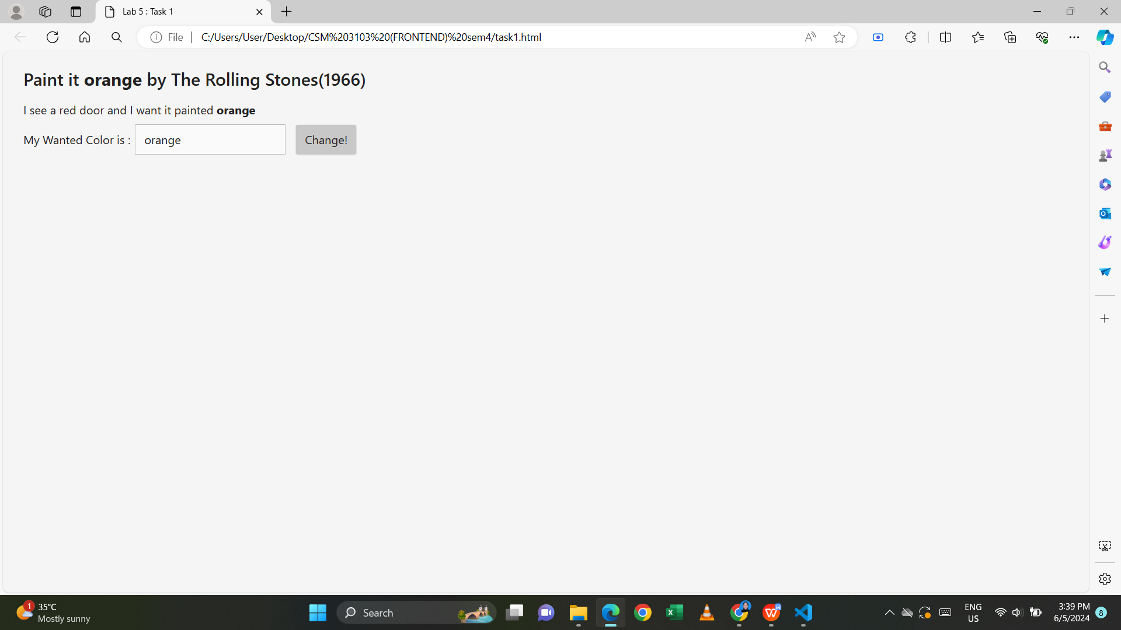

- only the text change to the ‘orange’ text. Not the whole sentence change to the orange color.

h. Rewrite the code: can refer to task 2 if in doubt

1. Instead of input field, change it to dropdown which display available color understood by HTML (use select tag)
2. Retrieve the value from the select tag
3. Change the color of all appropriate text to selected color

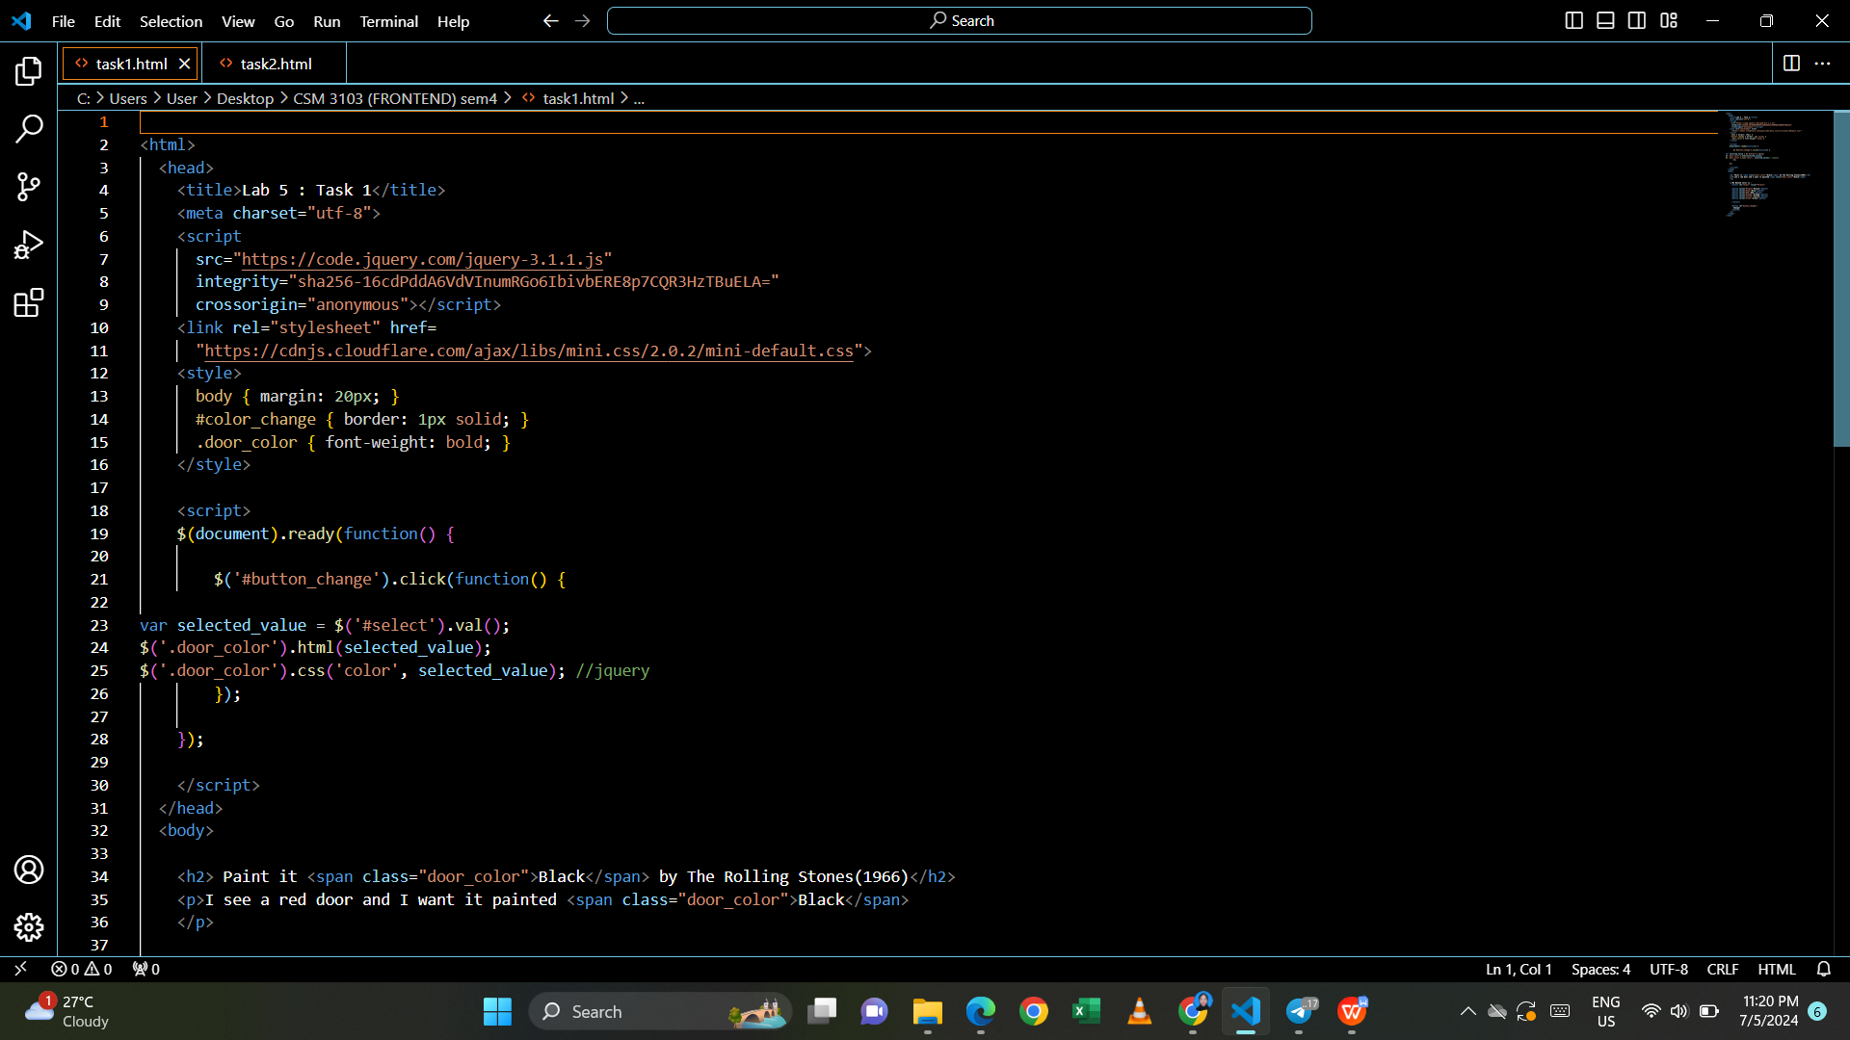

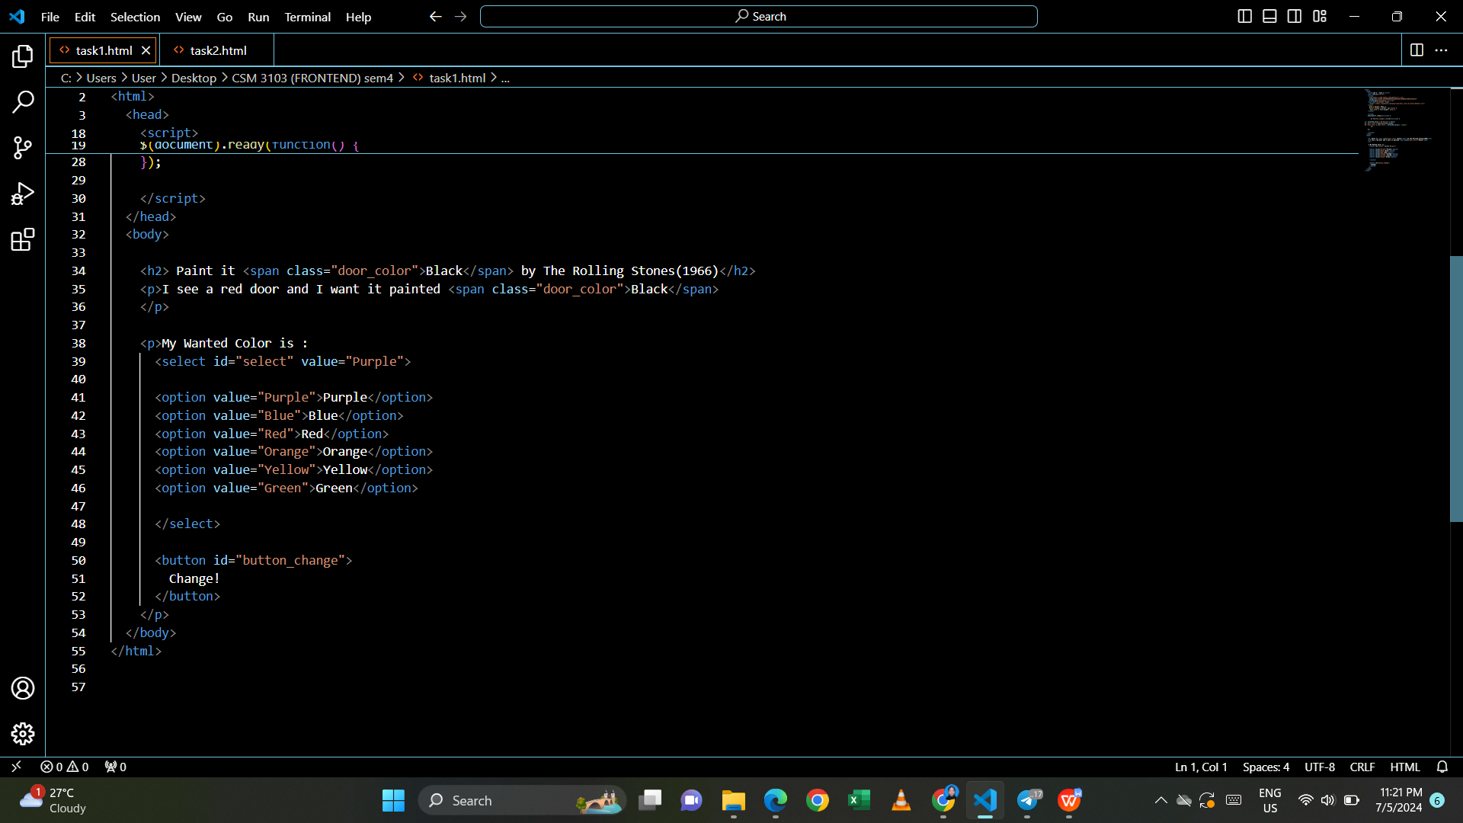

Output:

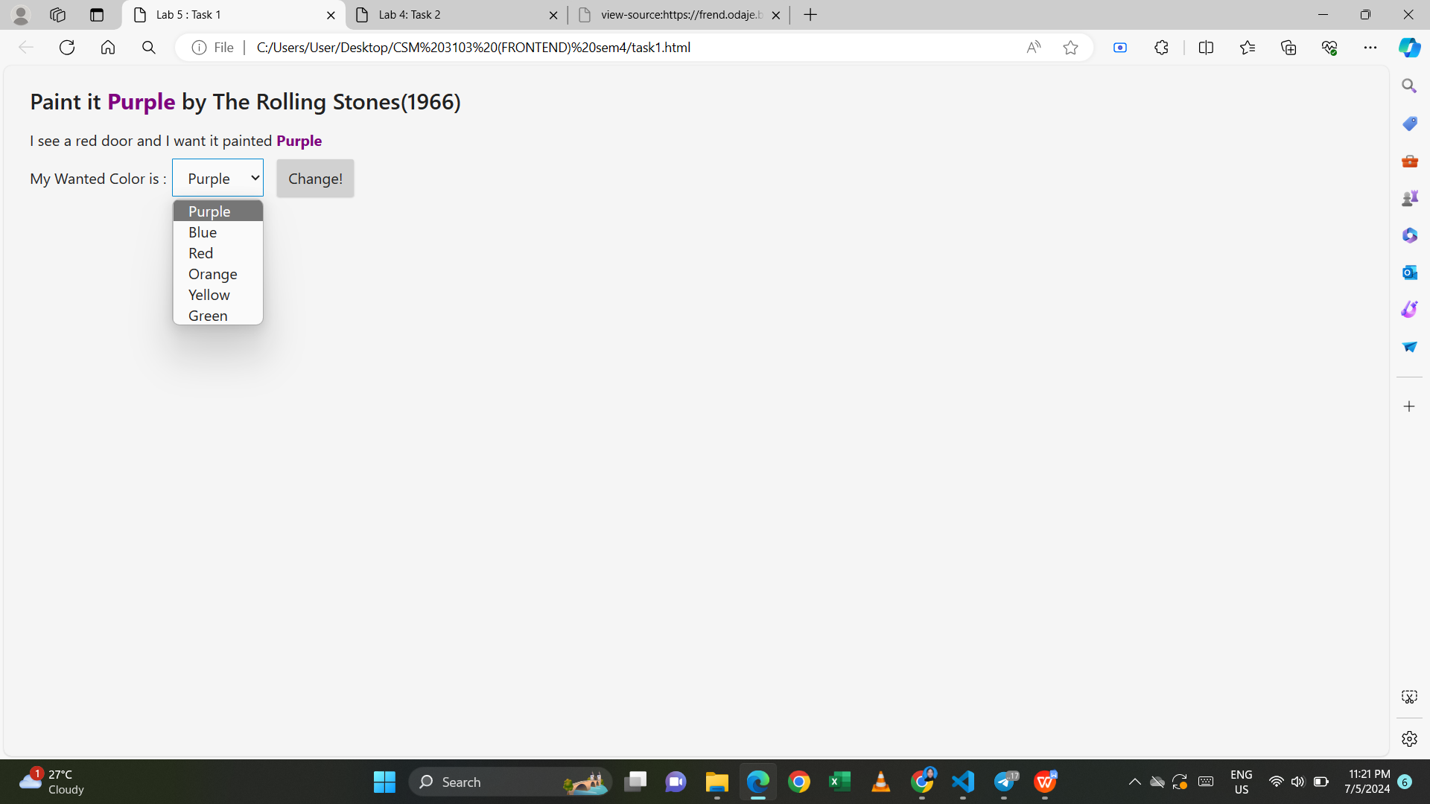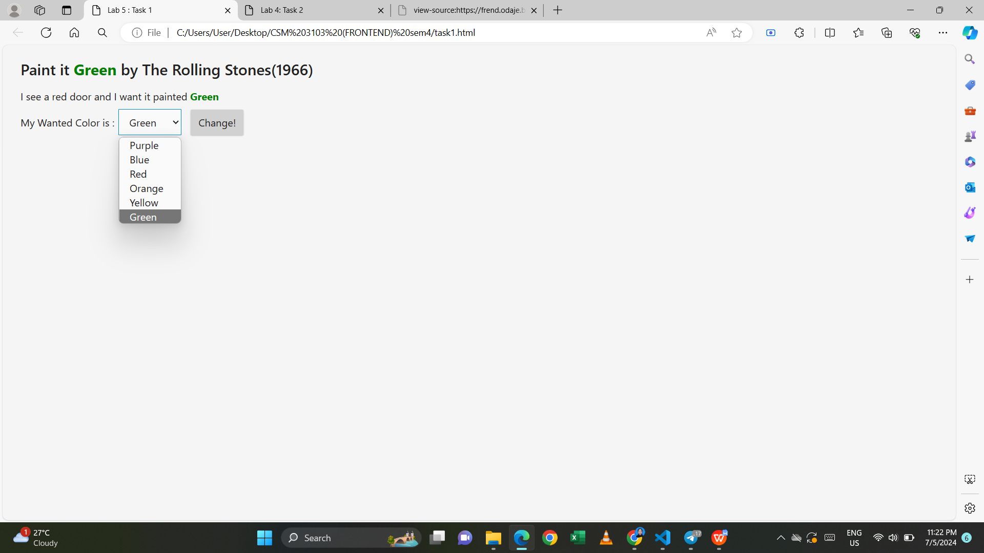

**Task 2**

1. What id’s that exist in the code above?

<div id="box1" class="box outlined"></div>

<div id="box2" class="box outlined"></div>

<div id="box3" class="box outlined"></div>

1. Open the file inside browser, what have you see in the browser?

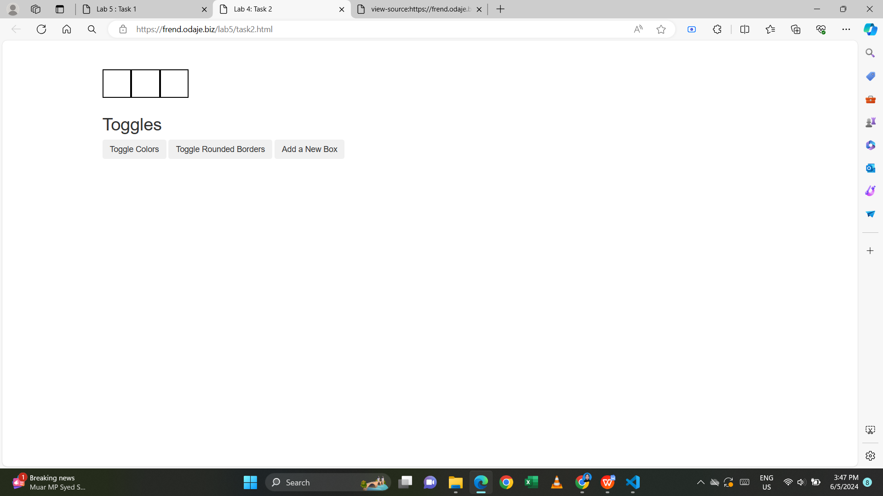

1. Click any button, what happened? Why

- doesn’t change anything

b. Your mission:

1. Click on Toggle Colors button: Toggles the color between white and cardinal
2. Click on Toggle Rounded Borders: Toggles the appearance of a border on the boxes
3. Click add a new box: adds one new box to the container

c. Implements the following to accomplished your mission

i. Add outlined class to each <div>. Refer to <div> for box2 as an example.

Save and open the file in browser

1. What changes have you see?

- Each box has a black border around it.

Test and evaluate your code:

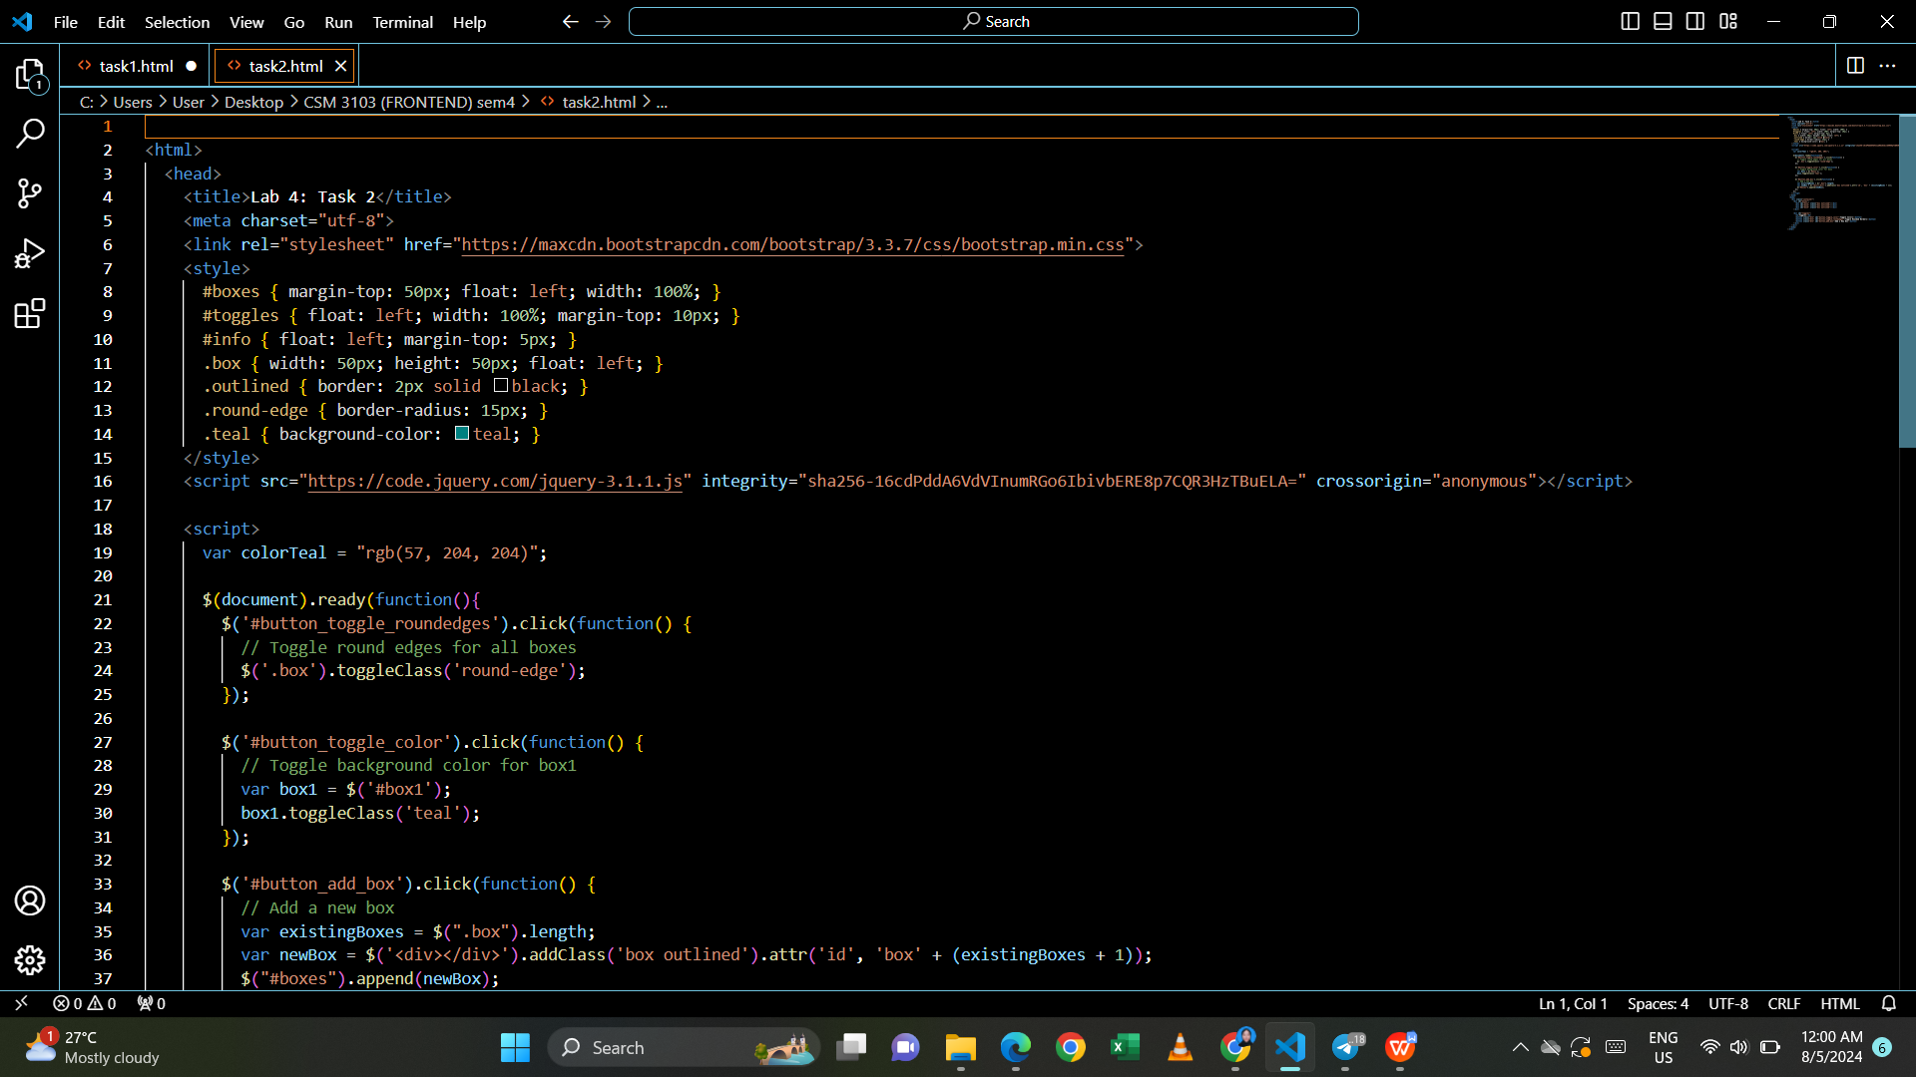

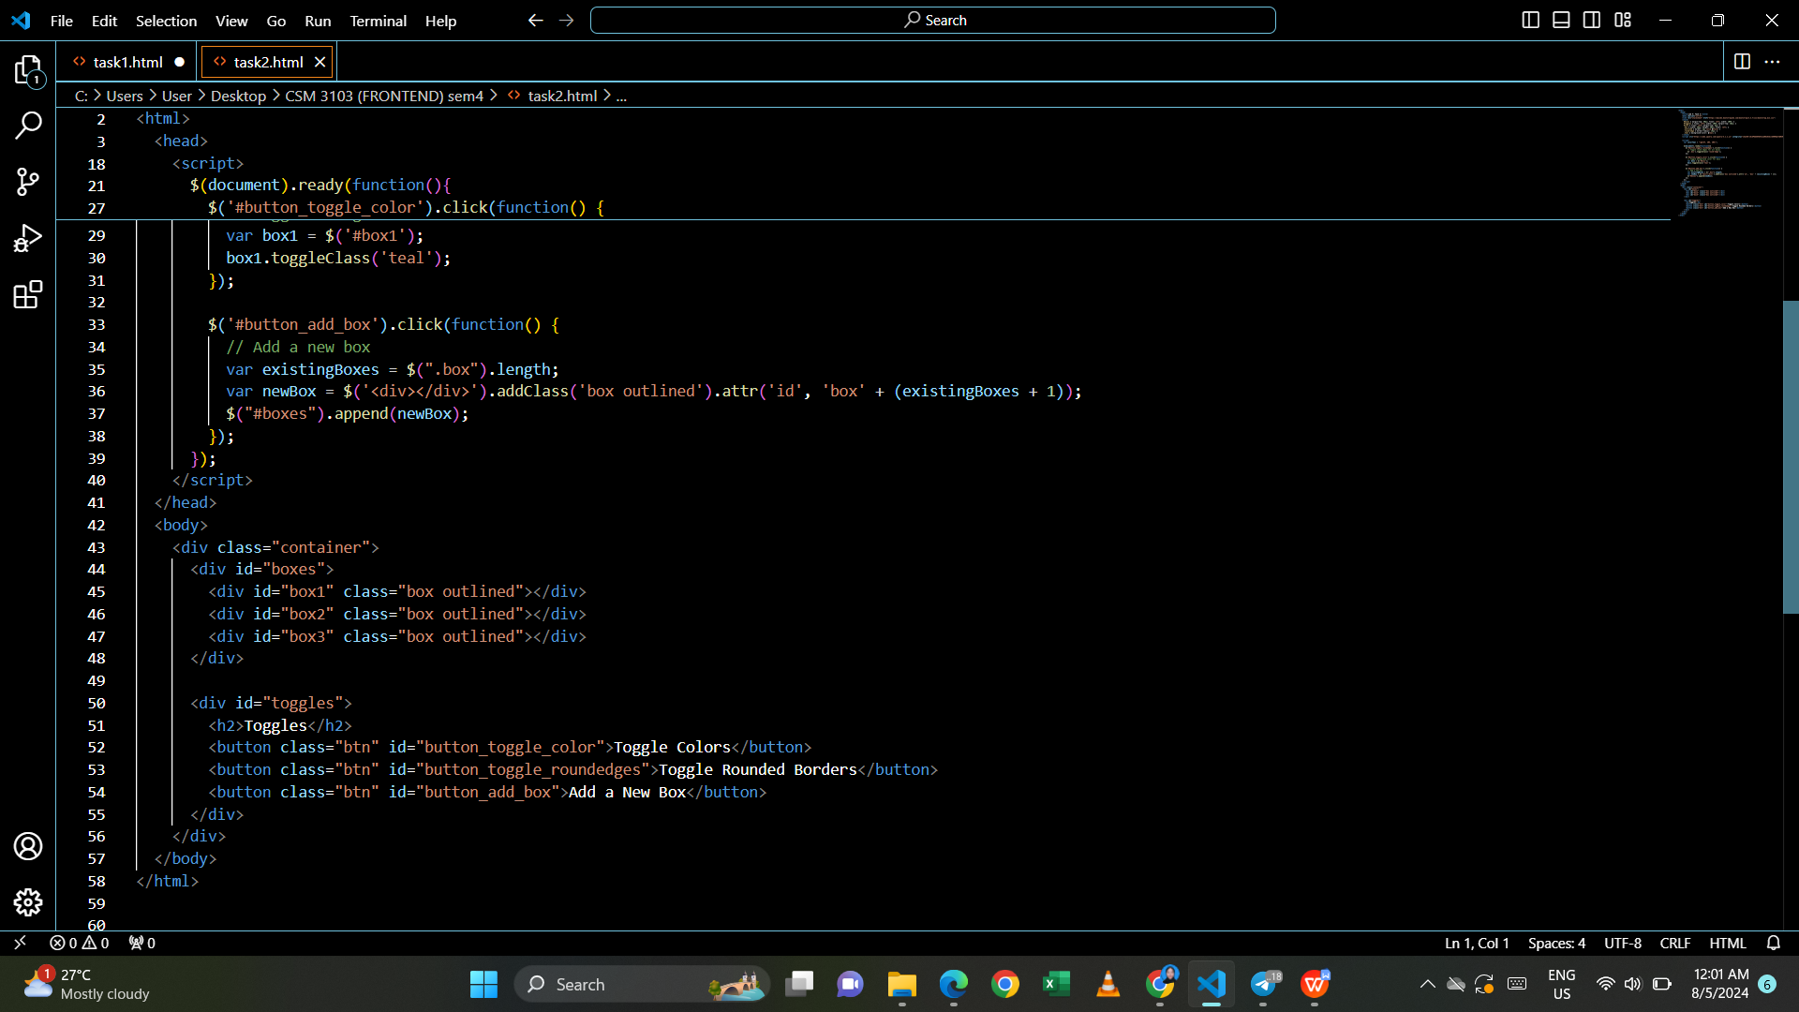

Output:

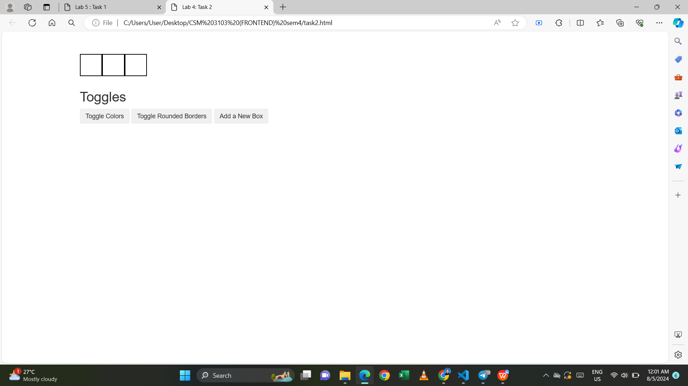

- when click Toggle Colors button

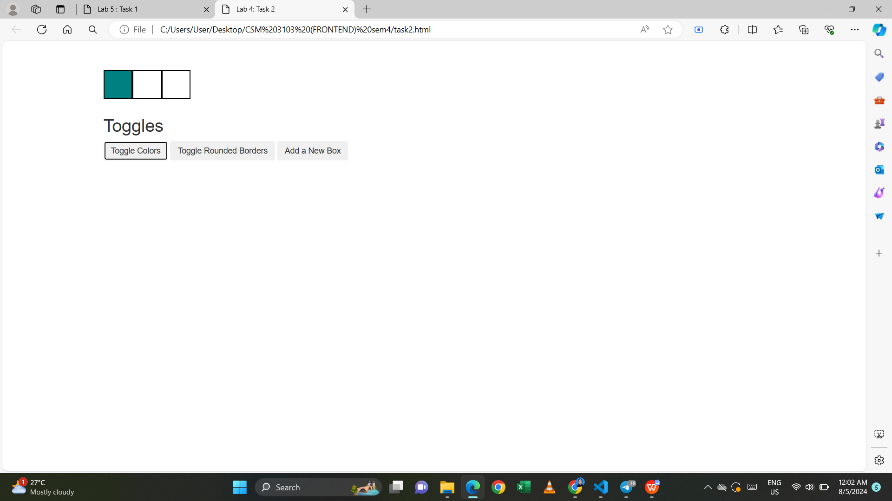

- when click Toggle Rounded Borders button

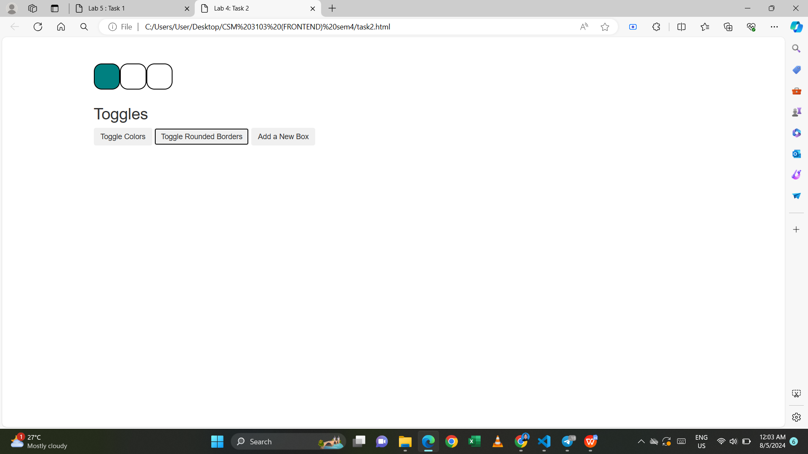

- when click add new box button

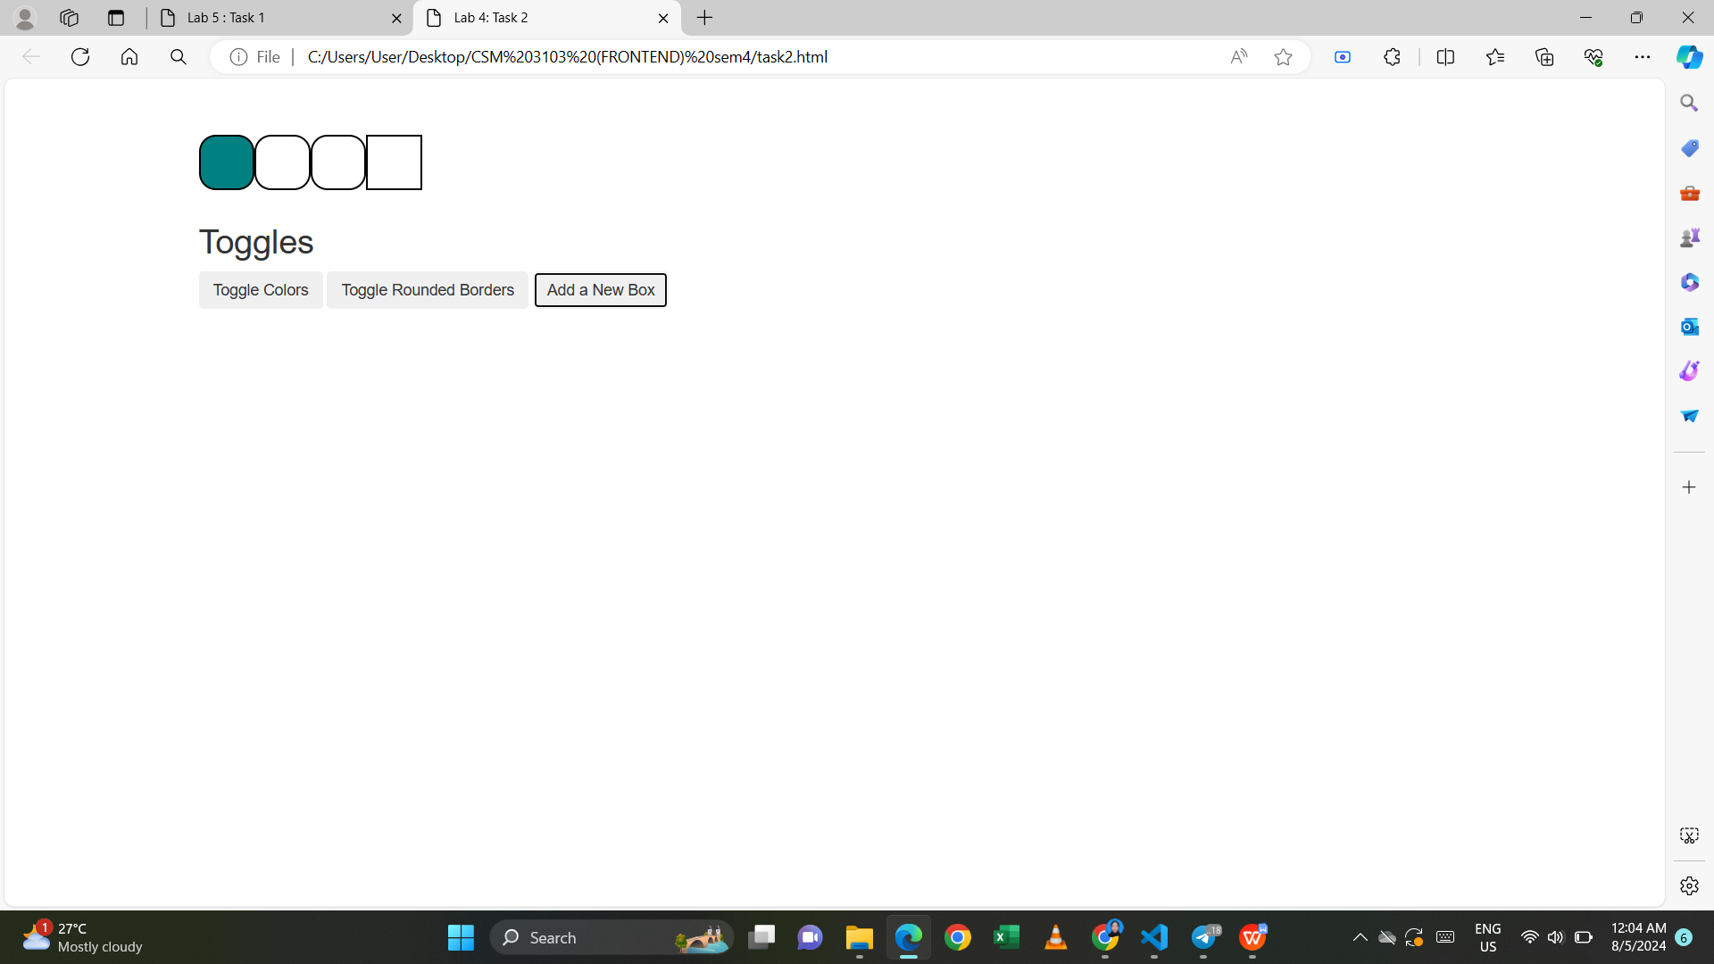

Modify the code above so that when button clicked, it only show one element which selected randomly.

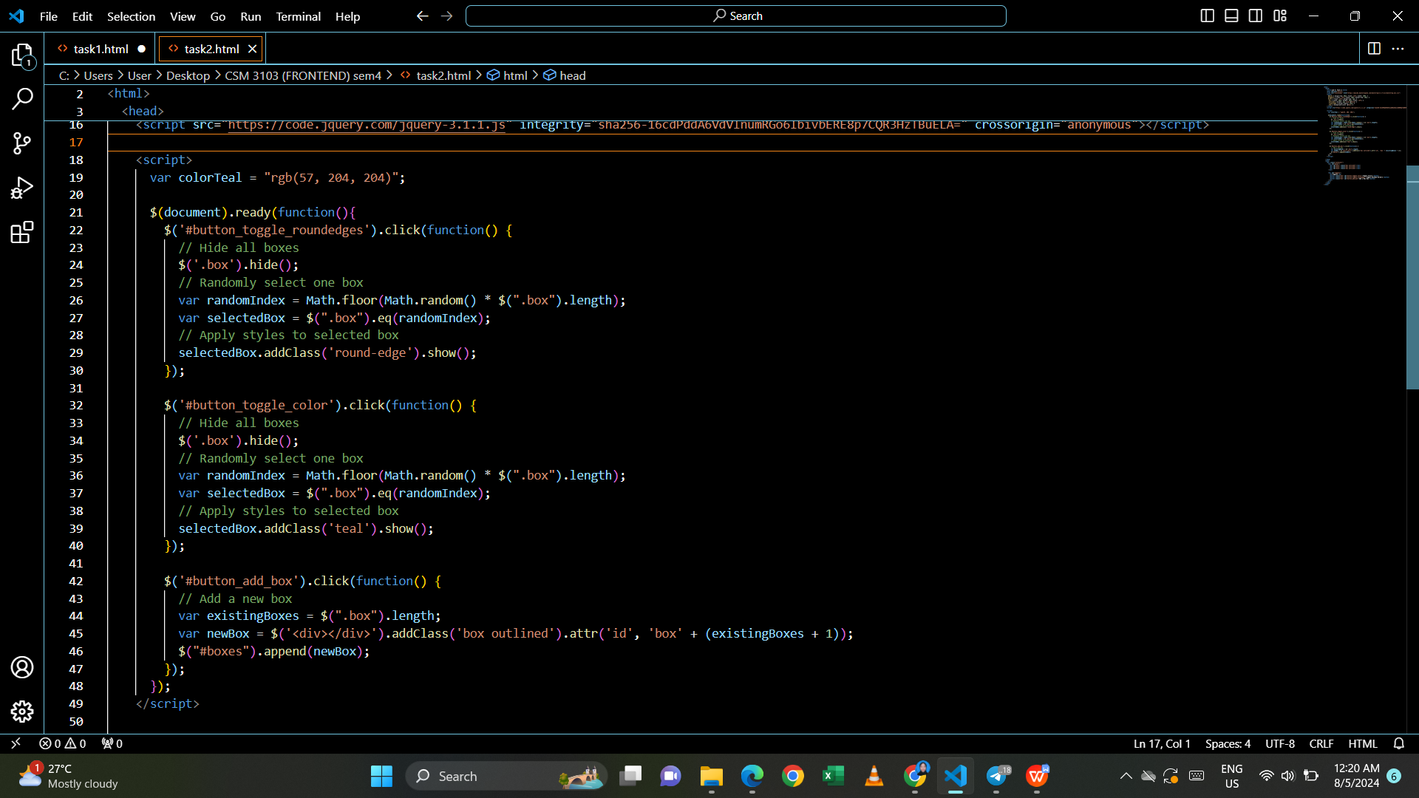

Output:

- when click Toggle colors button

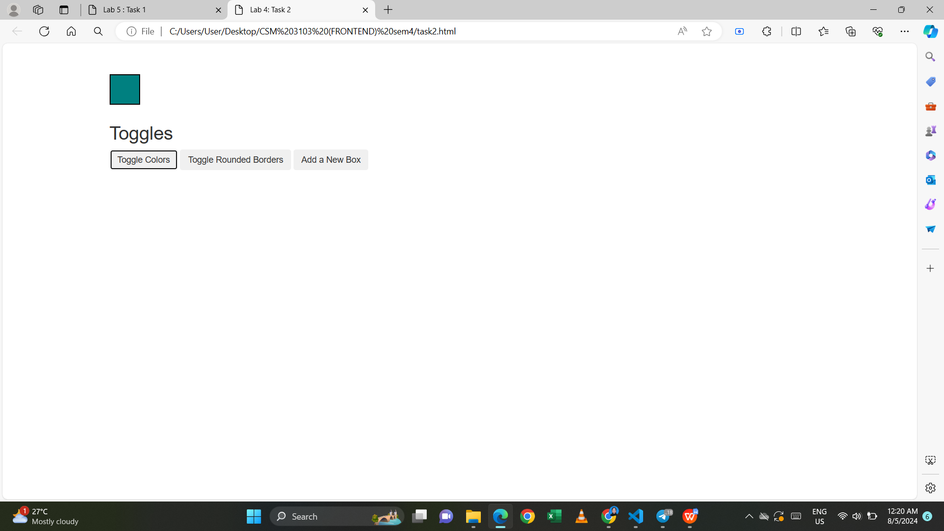

- when click toggle rounded borders button

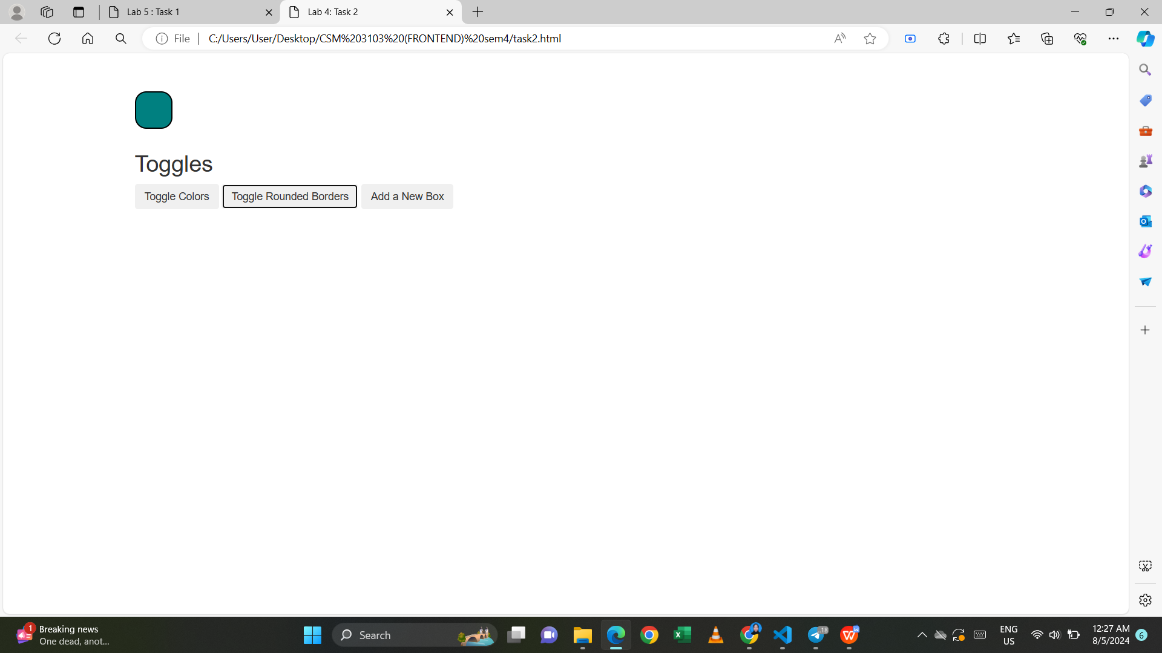

- when click add new box button

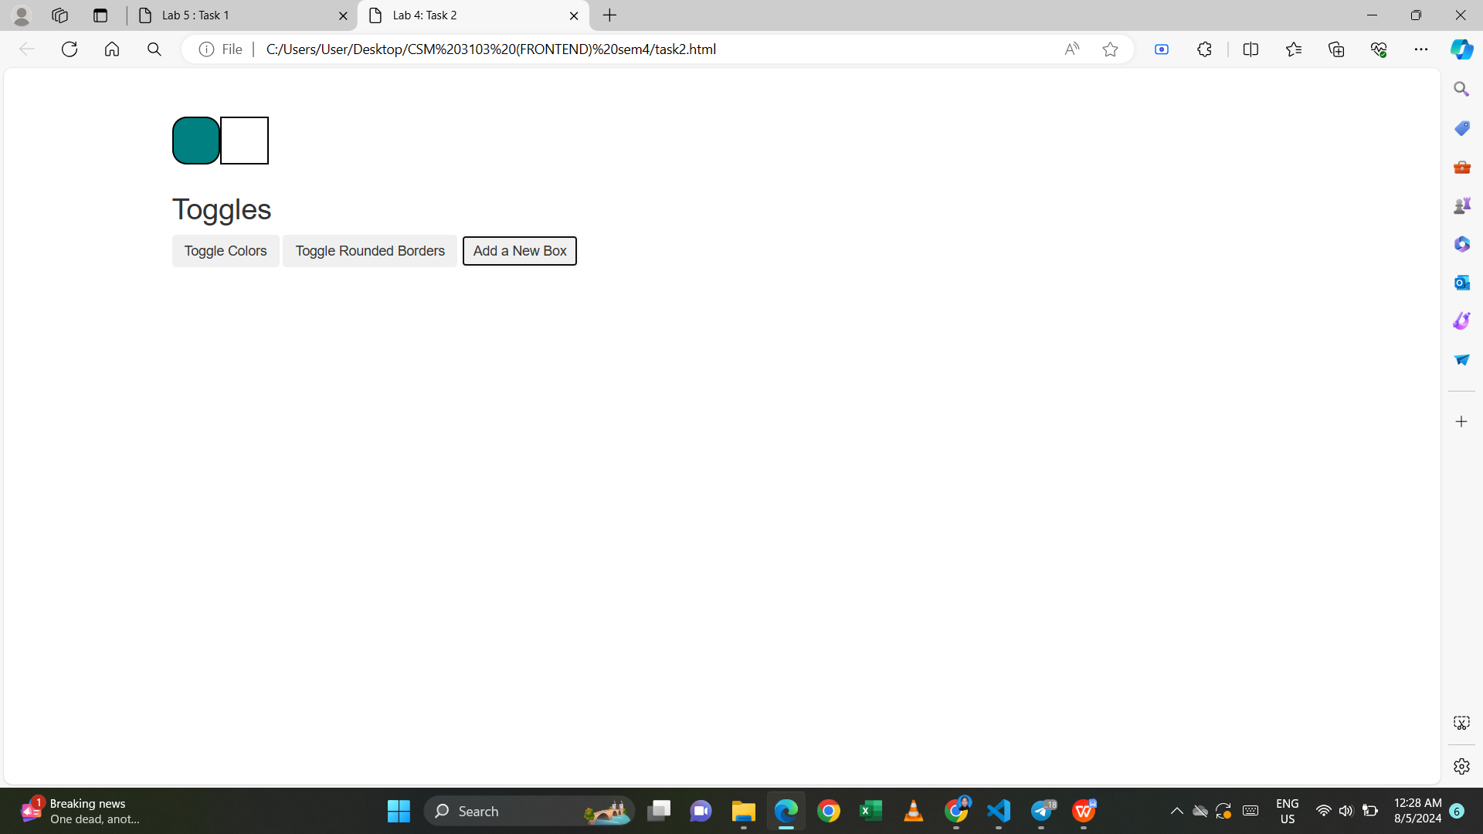

**Task 3**

1. Determine the id’s of each element
2. name_input: Div container for the name input.
3. date_input: Div container for the date input.
4. year_input: Div container for the enrollment year input.
5. color_input: Div container for the color ranking input.
6. Recognise any input element that associated with the form
7. Name Input: <input type="text" id="name">
8. Date Input: <input type="text" id="date">
9. Undergraduate Radio Button: <input type="radio" name="enroll_year" id="ugrad" value="ugrad">
10. Graduate Radio Button: <input type="radio" name="enroll_year" id="grad" value="grad">
11. Red Color Input: <input type="text" class="rank_color" id="red">
12. Blue Color Input: <input type="text" class="rank_color" id="blue">
13. Hot Pink Color Input: <input type="text" class="rank_color" id="hot_pink">
14. Mustard Color Input: <input type="text" class="rank_color" id="mustard">
15. Dark Green Color Input: <input type="text" class="rank_color" id="dark_green">

My code:

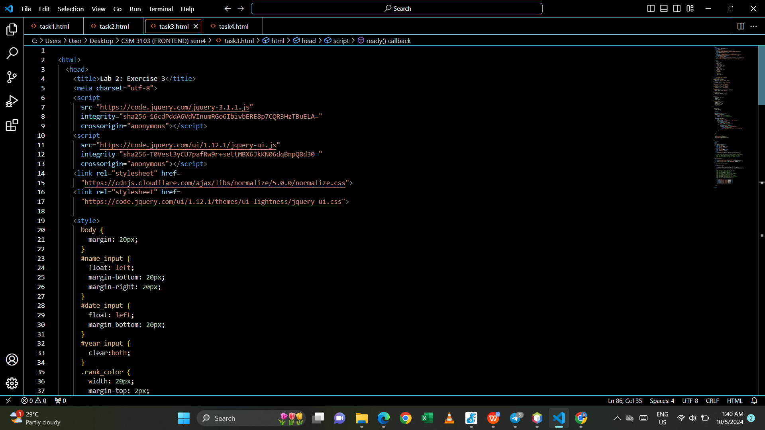

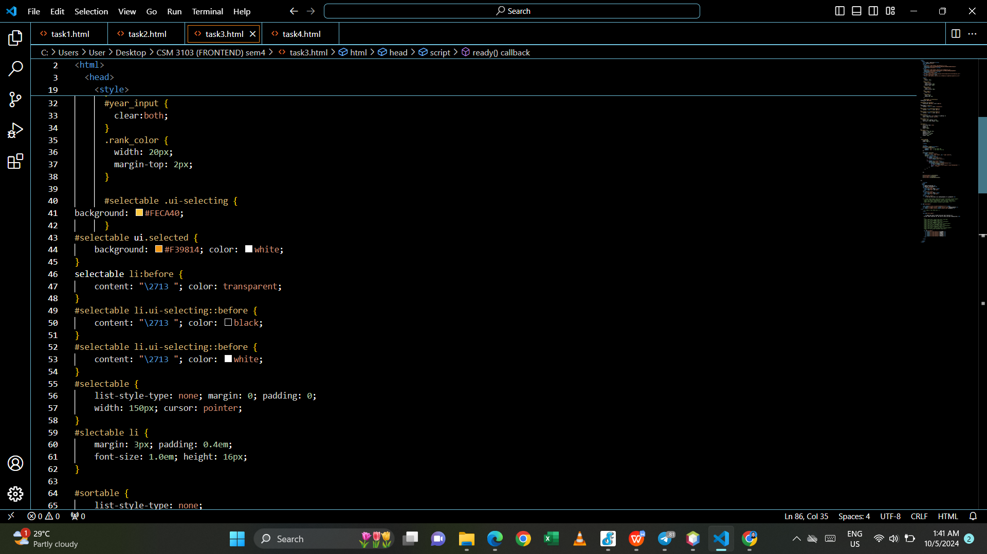

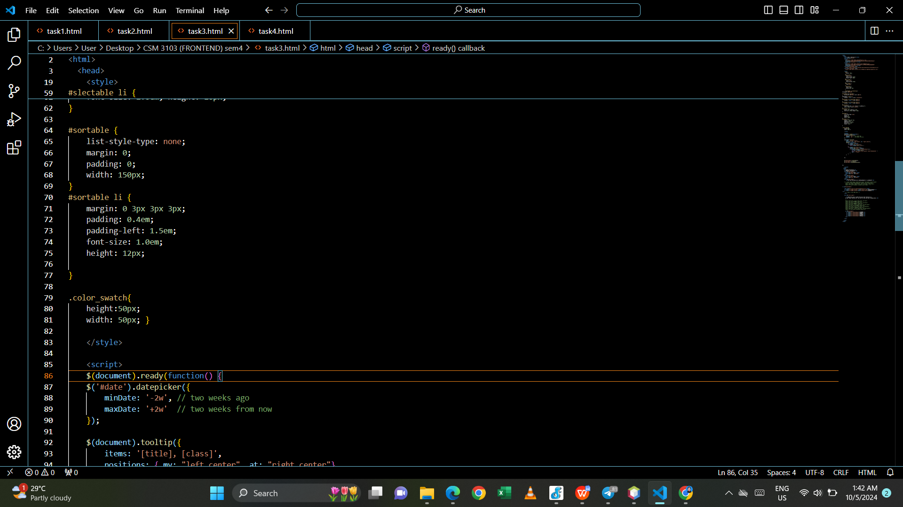

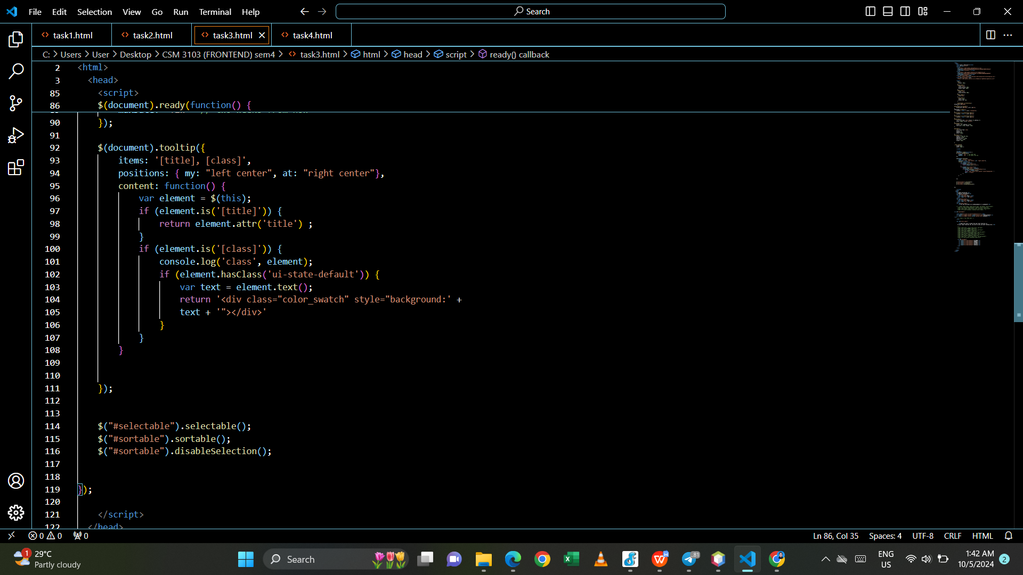

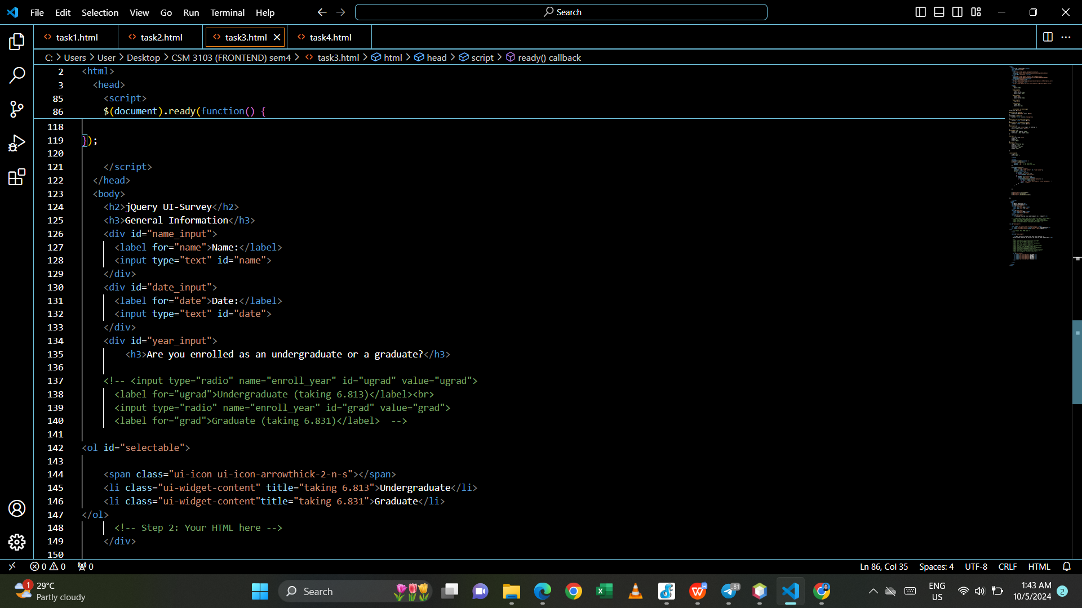

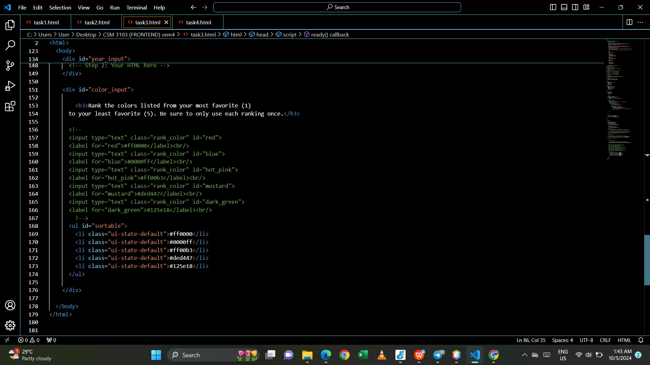

Output:

- I can move the colors in my favourite ranking.

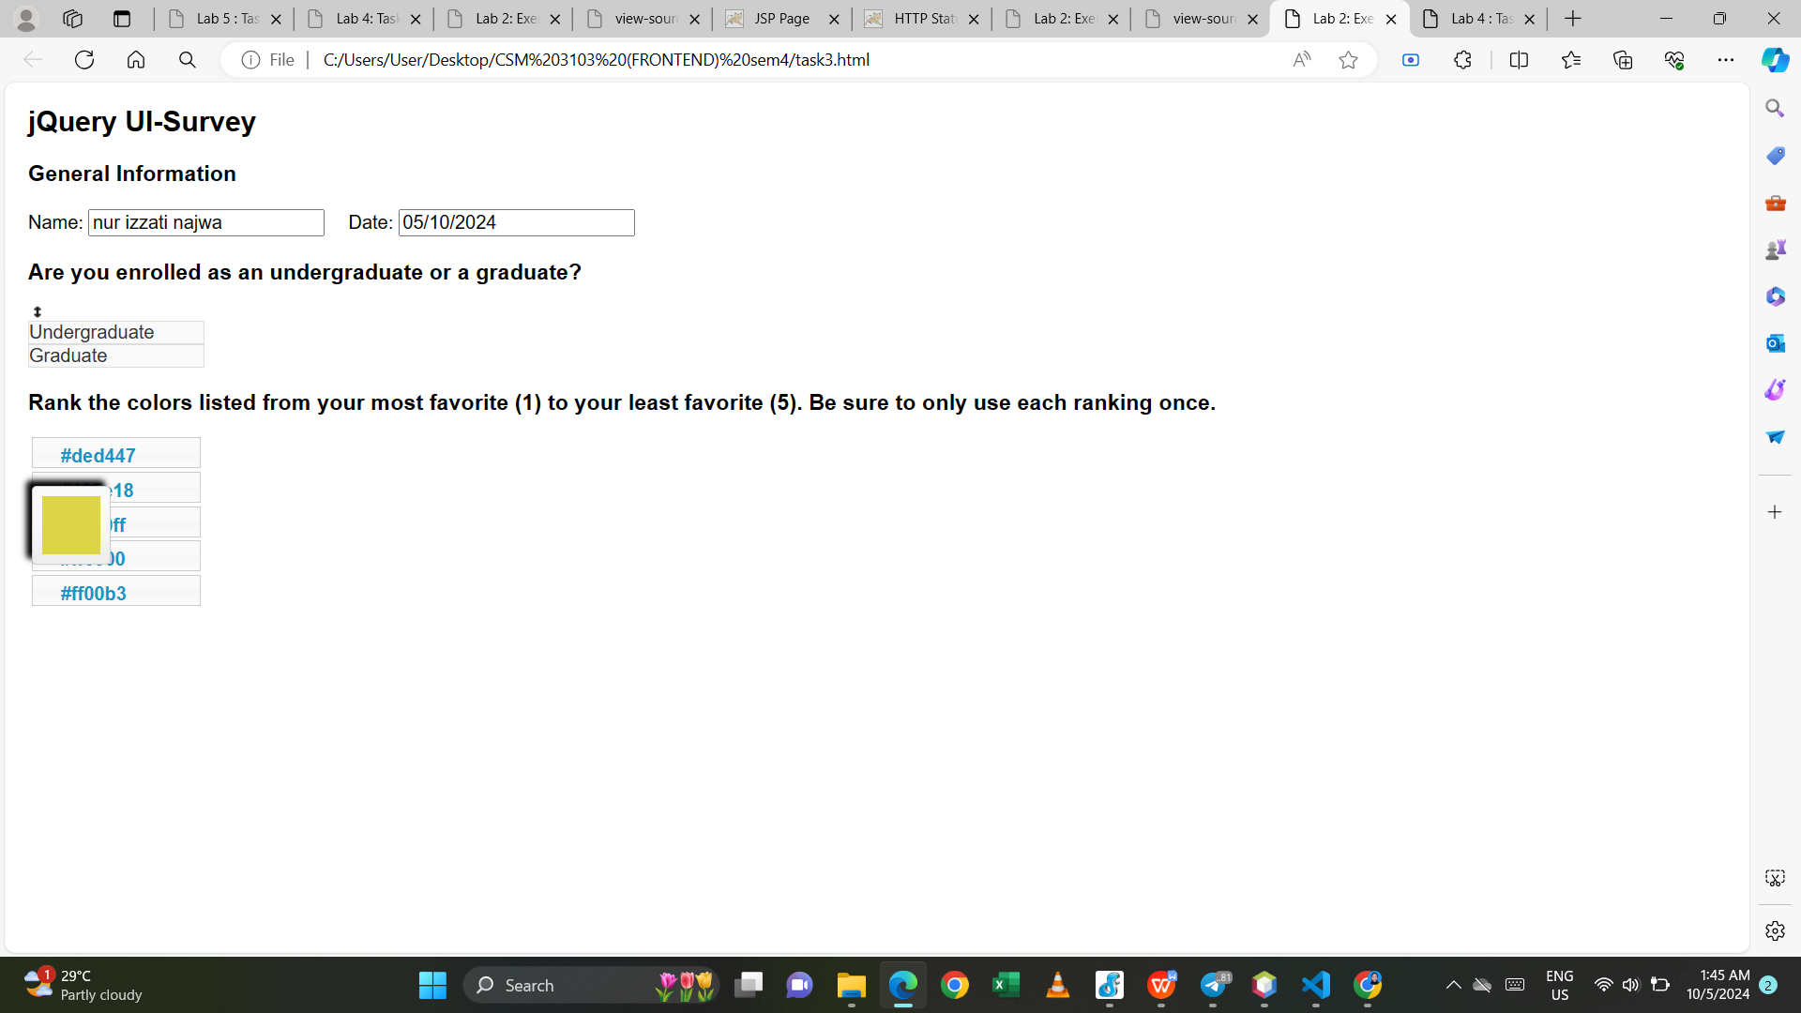

**Task 4**

My code:

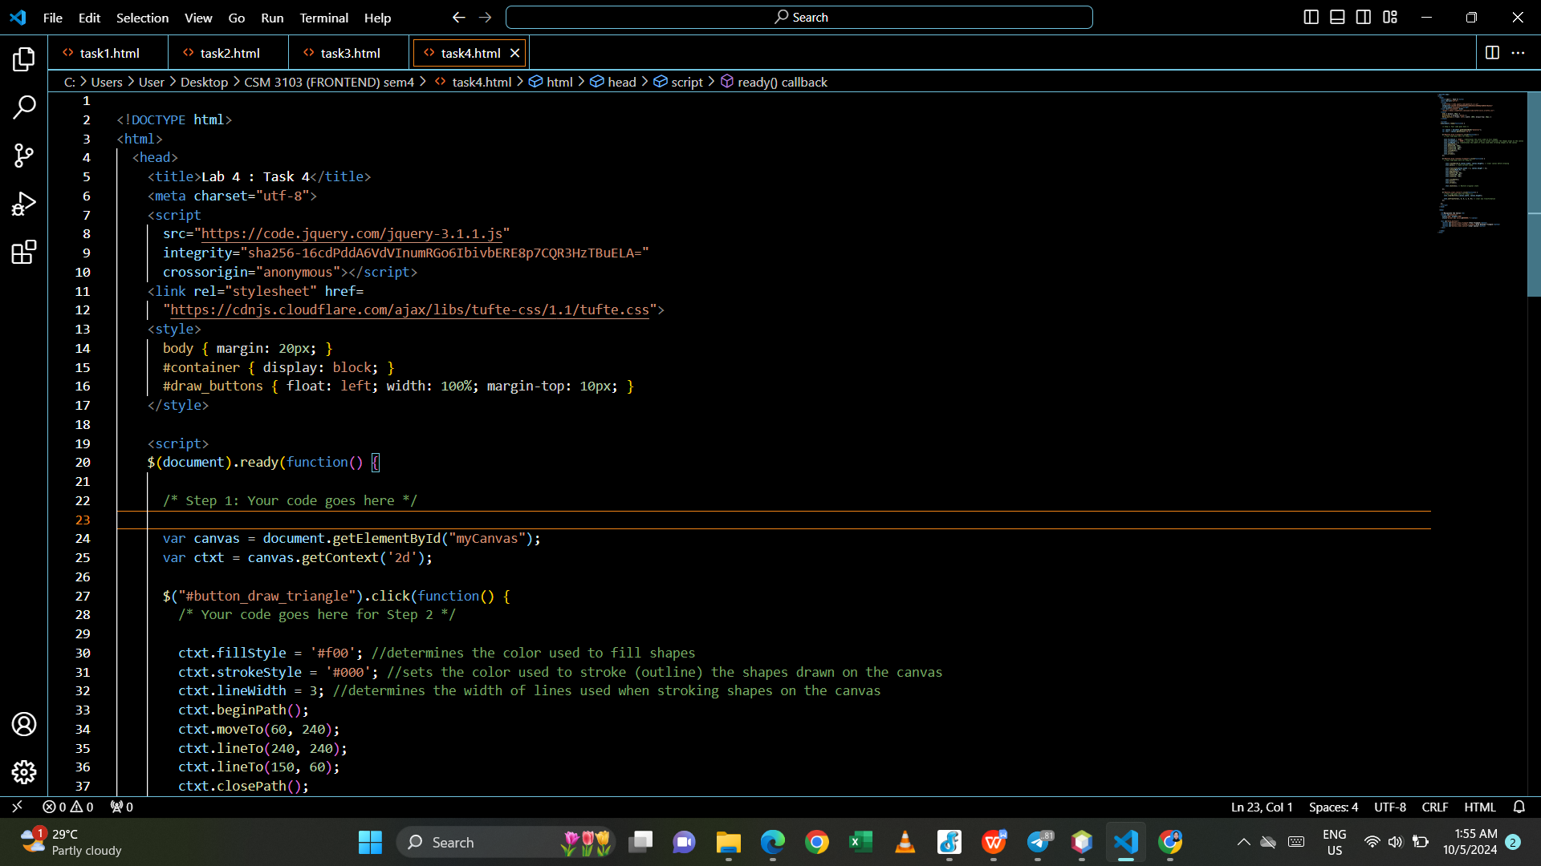

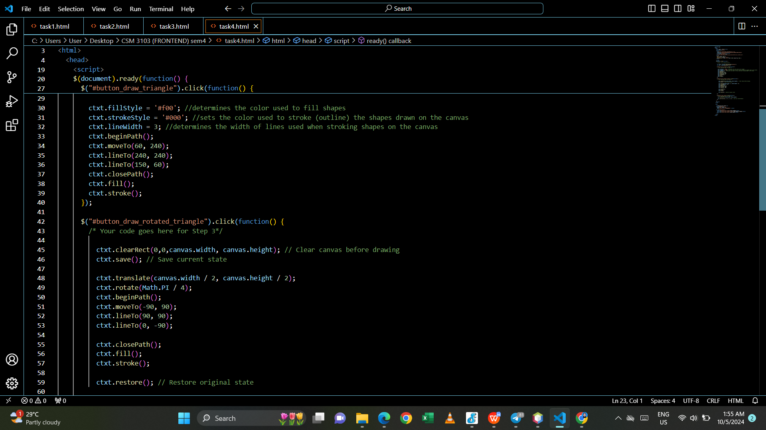

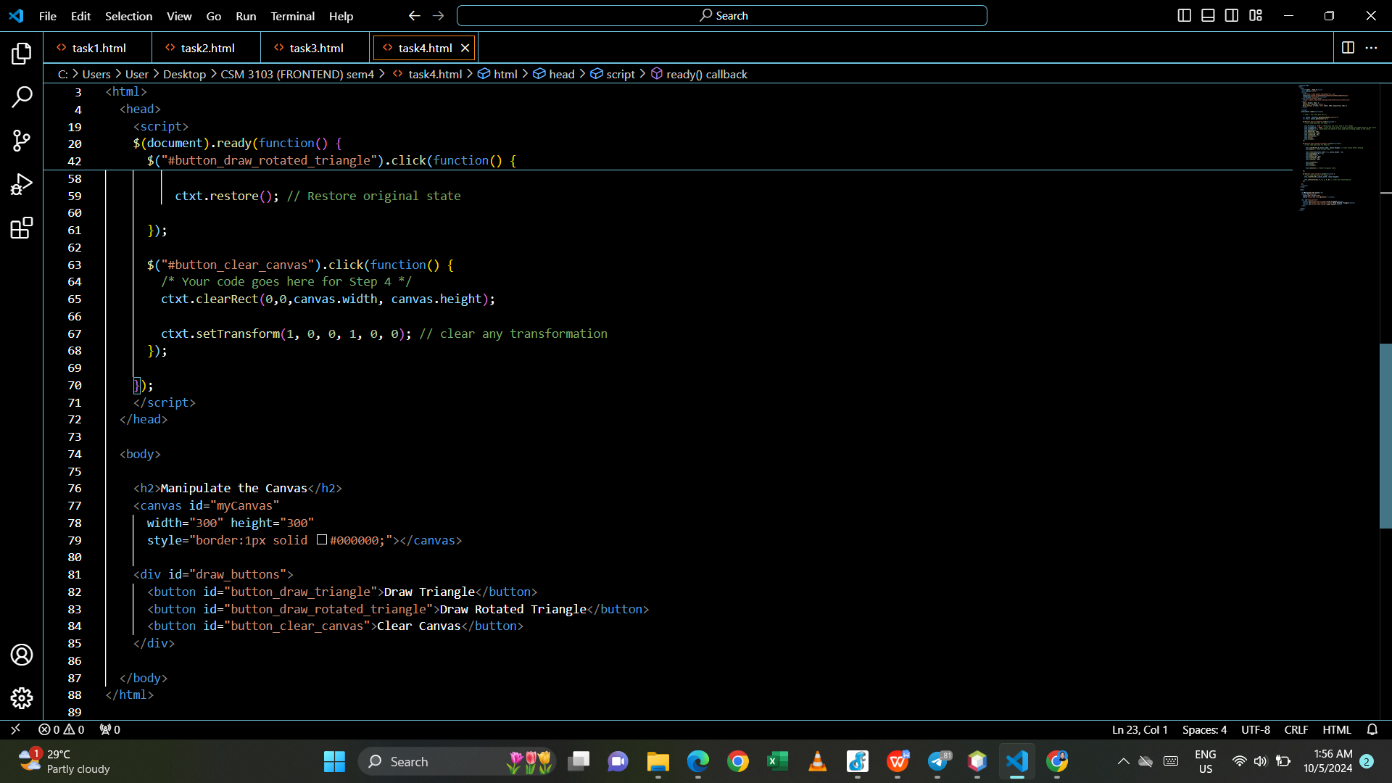

Output:

-when click draw triangle button

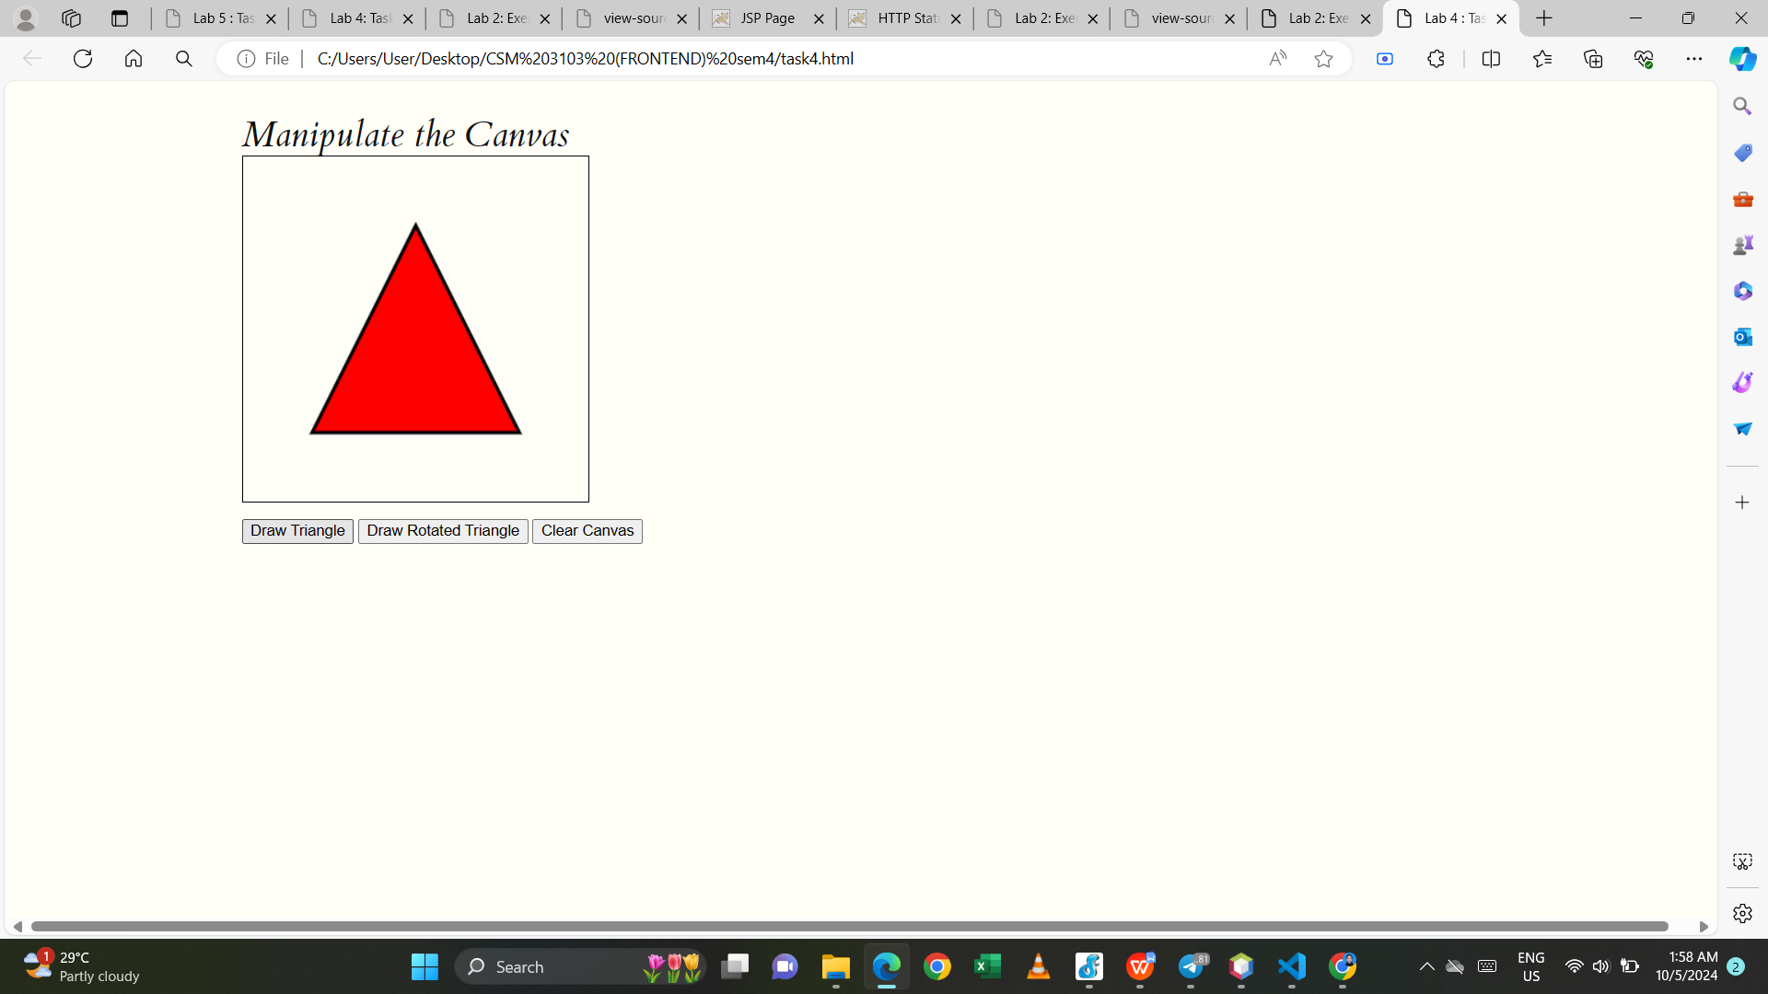

- when click draw rotated triangle button

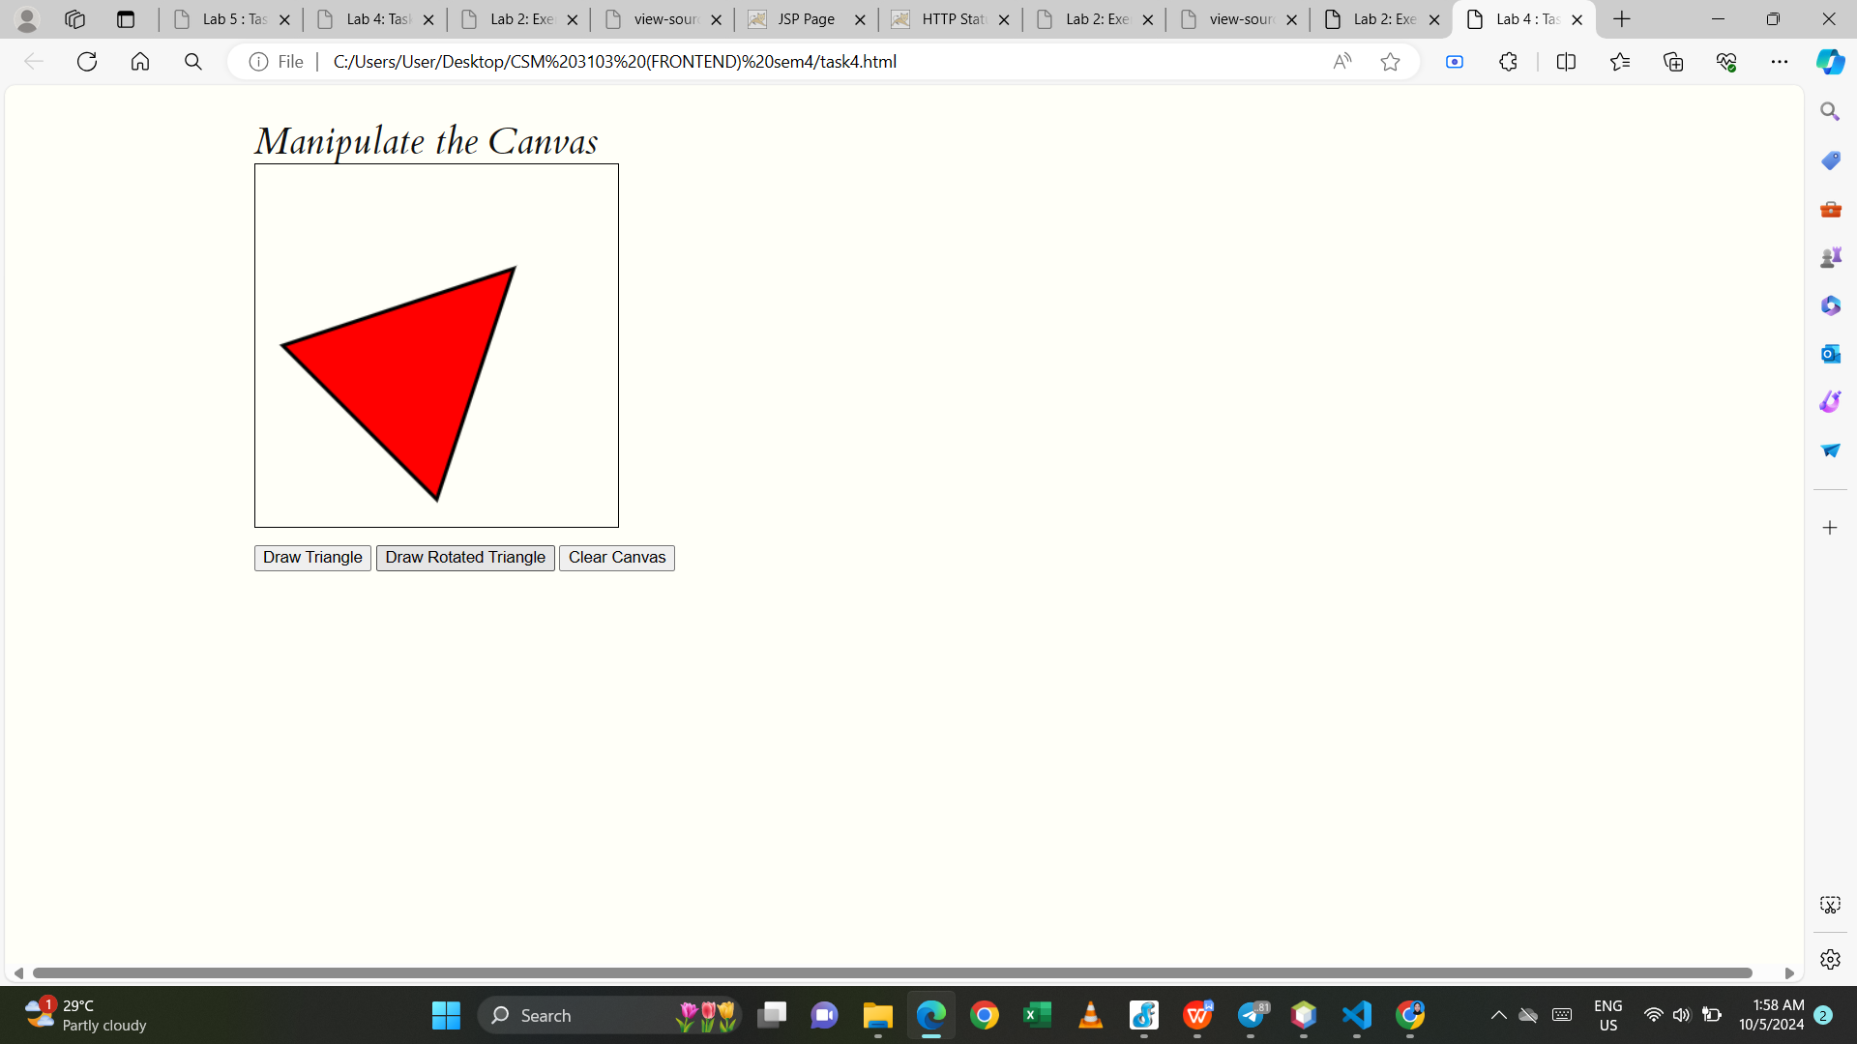

- when click clear canvas button

